

Grade 6 & 7 Boys

South Langley Basketball SUPER LEAGUE is specifically designed to develop individual and team skills through game situations. Grade 6 & 7 athletes will be given a reversible jersey, evaluated, placed into equivalent teams, and entered into a competitive, up-tempo, round robin league that will be followed by playoffs.

Each team will be provided with a coach and members of the South Langley Coaching Staff will referee all of the league and playoff games. All games will be played at Brookswood Secondary School.

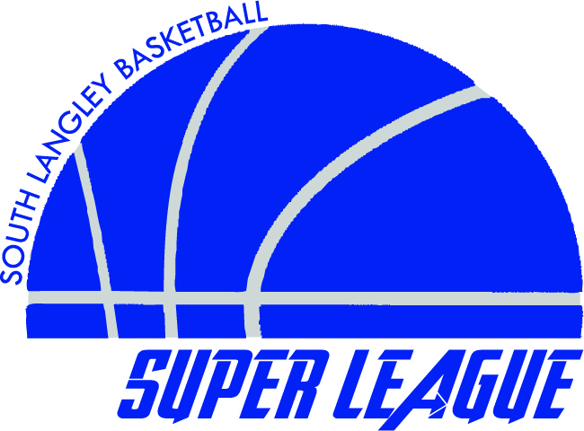
Games will run every Tuesday between 5pm & 6pm
Each game will consist of two 25-minute halves.
Price: $50

League Schedule:
Game 1: April 8th (Evaluation and ½ game)
Game 2: April 15th
Game 3: April 22nd
Game 4: April 29th
Game 5: May 6th
Game 6 May 13th
Semi Finals: May 20th
Finals: May 27th

Our coaches have a goal of developing and fostering basketball growth in the city of Langley. Off-season development is a vital aspect to the growth of every individual basketball athlete. We are offering a program of skill advancement and team building in a positive environment that is beneficial to every athlete.

For any information or inquiries email Coach Stewart: kstewart@sd35.bc.ca
Brookswood Secondary: 20902 37A Avenue Langley, British Columbia
---------------------------------------------------------------------------------------------------------------------------------------
South Langley Basketball Super League Registration Form

Last Name: ________________________ First Name: _____________________ Grade: ______
Email: ________________________ Phone: _____________________
School: ________________________
Emergency Contact: ____________________ Phone: _____________________

Release: in consideration of the acceptance of the application for registration, I intending to be legally bound, hereby for myself, my heirs, executors and administrators, waive and release any and all rights and claims for damages I may have against South Langley SUPER LEAGUE or its representatives and/or assignees, for any and all damages which may be sustained and suffered by me in connection with my association with or entry in this league and which may arise out of my traveling to, participating in or returning from the league.

Parent’s Signature for Participant: __________________________________
Register via email by forward the above information to kstewart@sd35.bc.ca

(Cheque or cash payable at Brookswood Secondary School before April 2nd, 2014)

Boys entering Gr. 6 or 7 (Sept 2014)

The Boys Metro Team plays in the competitive Basketball BC U13 Metro League that consists of teams from around the Fraser Valley and Lower Mainland. The regular season and playoffs run from September to February. Our team is coached and managed by members of the South Langley Basketball coaching staff.

Tryouts:
Tryouts will be held on “blah blah blah” at Brookswood Secondary.
You must attend at least 1 tryout in order to be considered for this team.
Tryout Cost is FREE

Practice & Game Schedule:
There will be 1-2 practices per week at Brookswood Secondary.
Games will be held every Sunday at the Langley Events Centre (LEC) starting in late October through to February.

Expectations:
Upon making the team, players are expected to attend the practices and games.

Costs:
Costs may vary but will be approximately $200.
This will cover practices, skill development, league fees, uniforms, and tournament fees.

Pre-Register Today:
To Register for Tryouts please contact
Coach Stewart at kstewart@sd35.bc.ca
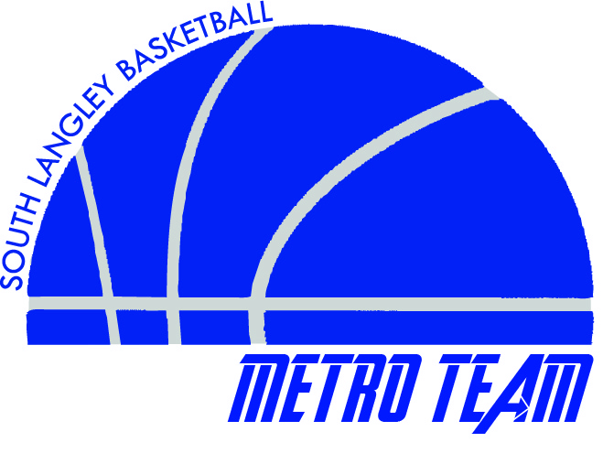
Please indicate your son’s name, grade, and school.

